Java Program Structure :

Package Statement ; //optional package example;

Import statement;//Optional

Interface Statement;//optional

class class_name

{

} //definition //optional

public class class_name //essential

{

public static void main(String args[])

{

}

}

Let’s use example of HelloWorld Java program to understand structure and features of class. This program is written on few lines, and its only task is to print “Hello World from Java” on the screen. Refer the following picture.

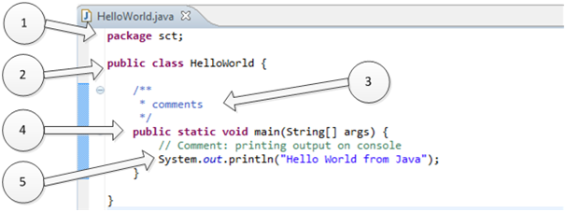

**1. “package sct”:**

It is package declaration statement. The package statement defines a name space in which classes are stored. Package is used to organize the classes based on functionality. If you omit the package statement, the class names are put into the default package, which has no name. Package statement cannot appear anywhere in program. It must be first line of your program or you can omit it.

**2. “public class HelloWorld”:**

This line has various aspects of java programming.

**a.** public: This is access modifier keyword which tells compiler access to class. Various values of access modifiers can be public, protected,private or default (no value).

**b.** class: This keyword used to declare class. Name of class (HelloWorld) followed by this keyword.

**3. Comments section:**

We can write comments in java in two ways.

**a.** Line comments: It start with two forward slashes (//) and continue to the end of the current line. Line comments do not require an ending symbol.

**b.** Block comments start with a forward slash and an asterisk (/*) and end with an asterisk and a forward slash (*/).Block comments can also extend across as many lines as needed.

**4. “public static void main (String [ ] args)”:**

Its method (Function) named main with string array as argument.

**a.** public : Access Modifier

**b.** static: static is reserved keyword which means that a method is accessible and usable even though no objects of the class exist.

**c.** void: This keyword declares nothing would be returned from method. Method can return any primitive or object.

**d.** Method content inside curly braces. { }

**5. System.out.println("Hello World from Java") :**

**a.** System:It is name of Java utility class.

**b.** out:It is an object which belongs to System class.

**c.** println:It is utility method name which is used to send any String to console.

**d.** “Hello World from Java”:It is String literal set as argument to println method.

**More Information regarding Java Class:**

* Java is an object-oriented language, which means that it has constructs to represent objects from the real world. Each Java program has at least one class that knows how to do certain things or how to represent some type of object. For example, the simplest class, HelloWorld,knows how to greet the world.
* Classes in Java may have methods (or functions) and fields (or attributes or properties).
* Let’s take example of Car object which has various properties like color, max speed etc. along with it has functions like run and stop. In Java world we will represent it like below:

1. package sct;
3. **public** **class** Car {
5. **private** String color;
7. **private** int maxSpeed;
9. **public** String carInfo(){
11. **return** color + " Max Speed:-" + maxSpeed;
13. }
15. //This is constructor of Car Class
17. Car(String carColor, int speedLimit){
19. this.color = carColor;
21. this.maxSpeed =speedLimit;
23. }
25. }

* Lets make a class named CarTestwhich will instantiate the car class object and call carInfo method of it and see output.

[view plainprint?](http://www.w3resource.com/java-tutorial/java-program-structure.php)

1. package sct;
3. //This is car test class to instantiate and call Car objects.
5. **public** **class** CarTest {
7. **public** **static** void main(String[] args) {
9. Car maruti = **new** Car("Red", 160);
11. Car ferrari = **new** Car ("Yellow", 400);
13. System.out.println(maruti.carInfo());
15. System.out.println(ferrari.carInfo());
17. }
19. }

Output of above CarTest java class is as below. We can run CarTest java program because it has main method. Main method is starting point for any java program execution. Running a program means telling the Java VIrtual Machine (JVM) to "Load the class, then start executing its main () method. Keep running 'til all the code in main is finished."